**AGREEMENT**

Total record reflecting the value of ZERO

**##As Discussed on call not required**

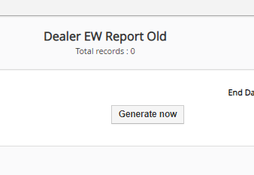

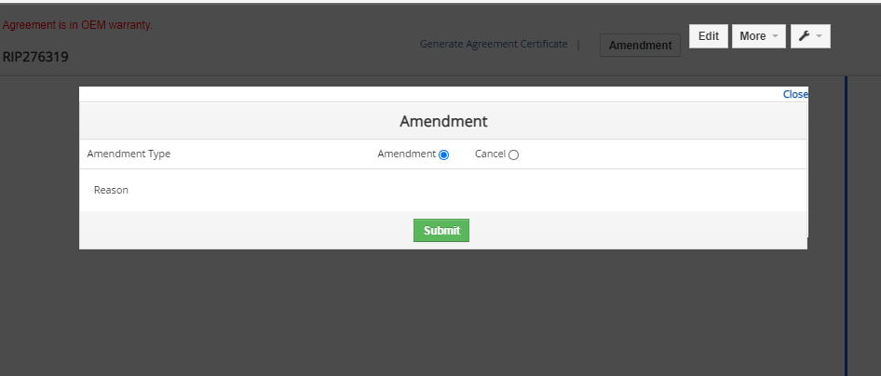

1. After clicking on Document, blank page, and jumps direct to the home page after clicking on back.

**##working correctly**

3.page is getting blank for adding part, labour, Miscellanious, Customer voice and symptoms,documents, and comment, and jumps direct to the home page after clicking on back. **##fixed**

**Claim**

1.These links are not working **##fixed**

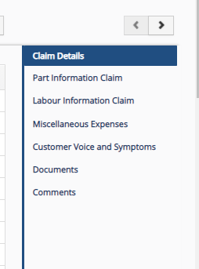

**EASY CARE SALES**

1. Not able to add documents for REC sales.

**## REC Sales do’t have any functionality of add document.**

**Easy Care Claim**

**Physical Document Tracking(Incorrect date is accepting)**

**##As Discussed on call not required**

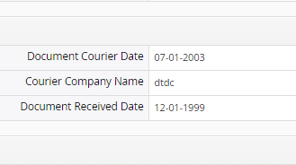

19/01/2021

There is no data in the labour code while searching the Labour Code.

